- Channels
The market is always in channels. Sometimes traders have to look at a higher time frame chart to see them. Most are not what textbooks and websites describe as channels.
However, traders know what channels really look like and they are very flexible when they choose points to draw lines. Once they see two points, they draw a line and watch to see if the market reverses if it get back to the line. They are constantly erasing lines that the market is ignoring and are always drawing new ones.
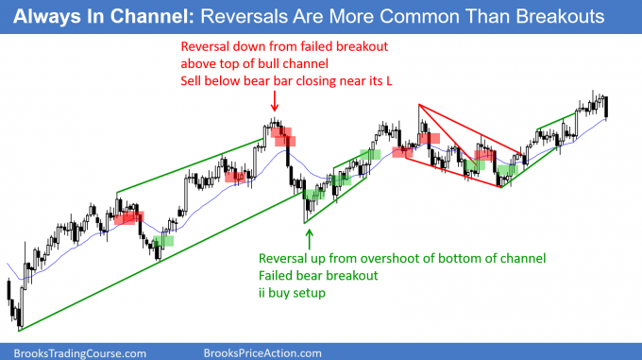Every market is always in a channel. Sometimes it is clearer on a smaller or higher time frame chart. Traders look to enter on reversals since reversals
are more common that breakouts.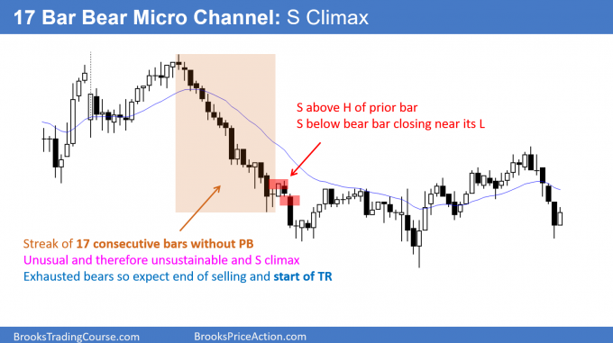A micro channel is a series of bars without a pullback. It is a strong trend, but once it reaches about 10 bars, it is unsustainable. It therefore is also a climax.
A climax typically evolves into a trading range.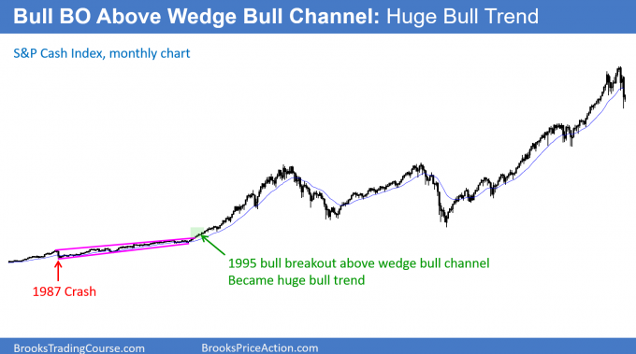The S&P cash index was in a wedge bull channel from the 1987 crash to late 1994.
It is difficult to see because the rally that followed a breakout above the bull channel has been huge. There is only a 25% chance of a successful breakout above a bull channel.

- Measured moves
The market often tries to do something twice. The result is that most tops are variations of double tops, most bottoms are variations of double bottoms, and trends often have at least a second leg with the size of the second leg related to that of the first leg.
Everyone is familiar with a Leg 1 = Leg 2 measured move. This i, where the market has a second leg that is almost identical to the length of the first.
Also, traders look for a measured move after a breakout from a trading range. They expect the move to be about the same size as the trading range is tall. The are many other types of measured moves that the computers use to either take profits or to enter reversal trades, and several are based on intraday gaps, or the height of breakouts.
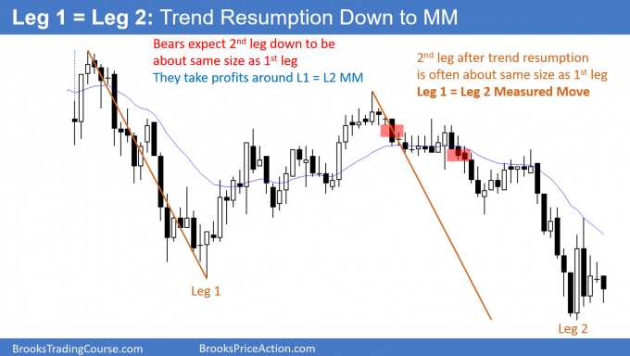When there is a pullback from a trend, the trend typically resumes. The 2nd leg is frequently very close in size to the 1st leg. This is a Leg 1 = Leg 2 Measured Move. Traders look to sell a reversal down for a test of the Measured Move target.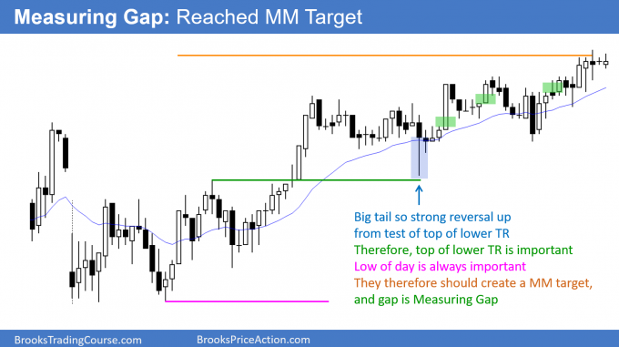When there is a breakout, the trend often continues for a measured move based on the height of the earlier range. Traders buy the bull trend and any pullback. They especially like a pullback that tests the breakout point, but then reverses back up.

- Trading range reversals
Even before a trading range is obvious, the market usually has signs of two-sided trading that alert traders to a possible trading range day. When that is the case, the market often races to the top with enough momentum to make traders erroneously believe that they can buy a small pullback and reasonably expect a second leg up. Similarly, they see a big bear trend bar at the bottom and then begin to sell bounces because they do not understand what is actually happening.
The market regularly gets vacuumed to the top, where bulls take profits instead of buying more, and the bears appear out of nowhere. Both the bulls and bears expect the test of resistance to lead to a failed breakout.
The opposite is true at the bottom. When the market gets near support, bear scalpers sell even more, expecting the market to fall just a little more. Bulls stop buying because they are confident that the market will reach the support and probably poke through it. Why buy now when they can buy lower in a few minutes?
The result is that the market creates strong bear bars at the bottom as it is vacuumed down to support. Instead of follow-through selling, buyers come. The bears buy to take profits and the bulls buy to initiate longs.
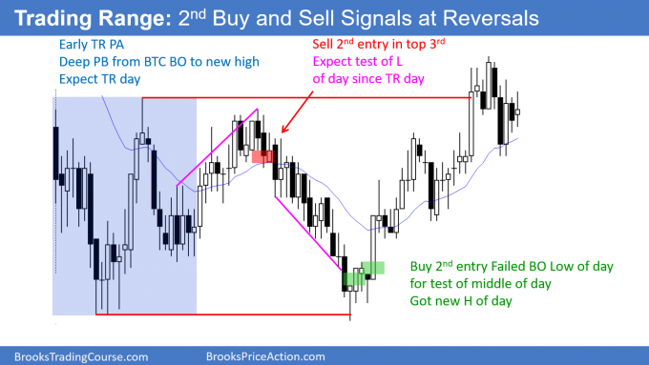The legs up and down in a trading range are often strong. When they are, traders have a higher probability of making money if they wait for a 2nd signal.
When traders start out, they often do not realize that the market is forming a trading range until the day is over. The bars often give early signs, as they did here. There were many bars with prominent tails, lots of pullbacks, yesterday ended in a tight trading range (markets have inertia and tend to continue what they have been doing), and few areas of 2 or 3 consecutive big trend bars. This means that the bulls and bears were disappointed by the follow-through.
Beginners feel confused and disappointed by the repeated reversals, not realizing that these feelings are the hallmarks of trading ranges. When experienced traders detect those feelings, they look at them as opportunities. They bet that every breakout will reverse and they look to buy low, sell high, and scalp.
Even when the market trended down at midday, they expected the breakout to the new low of the day to fail. This is because that’s what usually happens on trading range days. They bought the reversal up, betting that the rally would get back above the breakout point (the low of the first hour) and back into the trading range.
- Opening reversals
The components of an opening reversal pattern are:
- Usually fast move to a magnet (support or resistance)
- Reversal in 1st 60 – 90 minutes that leads to a swing for the next few hours or the entire day
Most strong bull trend bars on the daily chart have at least a small tail on the bottom, which is usually caused by an opening reversal (a selloff on the open that reverses up, and it is therefore a reversal pattern). Similarly, most bear trend bars on the daily chart usually have a tail on top caused by an opening reversal down.
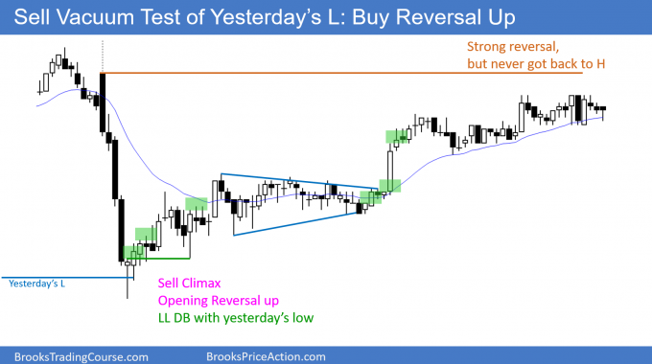There was a huge selloff on the open. It was a sell vacuum test of yesterday’s low, which is always a good candidate for support. The market rallied for the rest of the day.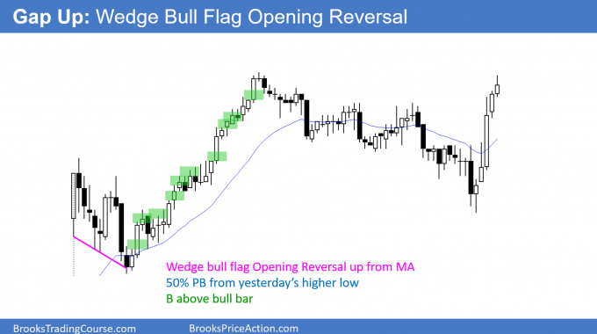After a gap up, the market pulled back to the 20 bar EMA. The reversal up was the 3rd rally attempt and therefore this Opening Reversal was a wedge bull flag test of the EMA.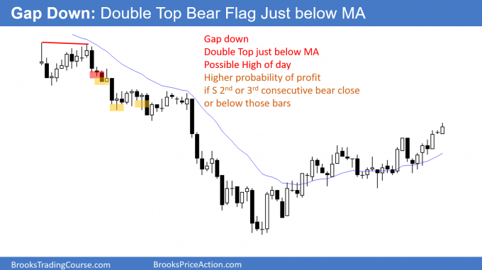Whenever there is a gap down, traders will watch for a double top bear flag around the EMA. They will sell the reversal down, hoping for an early high of the day and a bear trend.

10 Magnets (support and resistance)
The final pattern in my 10 best price action trading patterns is more of a concept than a setup. The market is always testing as it tries to establish a price range. It usually cannot tell if it has gone far enough up or down until it goes too far.
Support is any price below the market where buyers might come in, as either bulls buy to create new longs or bears buy to take profits. Resistance is any price above the market where bulls might take profits on longs and bears might short.
Common magnets include the tops and bottoms of trading ranges, prior highs and lows, trend lines, channels, measured move projections, and moving averages. Computers control the market, and all support and resistance is based on things that computer programs can calculate. The result is that the market often accelerates near the target once a substantial number of algorithms believe that the target will be reached.
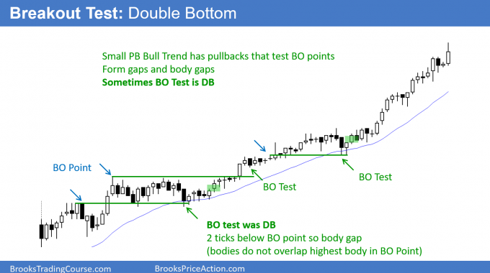When a market breaks above a prior high, it often pulls back to test that breakout point.
Bulls will buy a reversal up.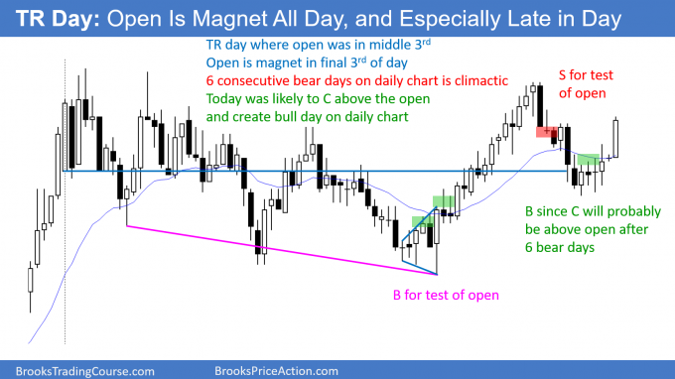A trading range day often oscillates around the open all day. If the market is near the high or low of the day in the final 2 hours, look for a reversal toward the open.
Most trading range days end the day around the open.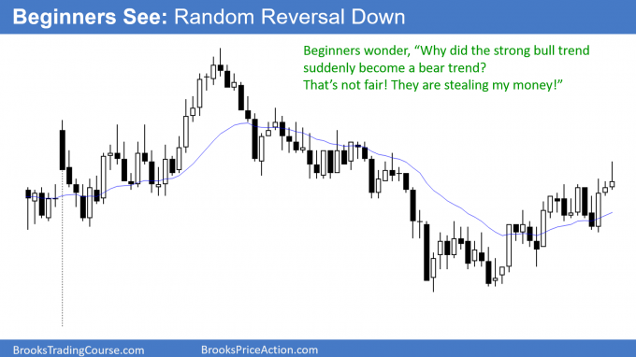Beginner gets upset by strong rally suddenly becoming endless bear trend.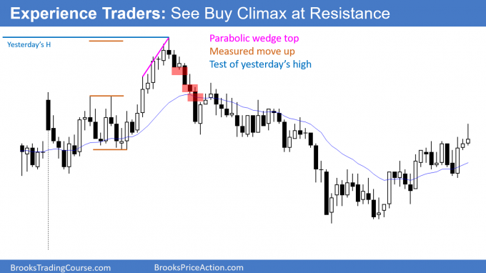Experienced trader knows where resistance is and looks for a reversal down. Any strong rally to resistance can simply be a buy vacuum test of the resistance.

Filed Under: Price Action Tagged With: Price Action Patterns, Price Action Trading


About Al Brooks
Al Brooks is a full time professional price action day trader who understands what a trader goes through to achieve his goal of making money, and he is a strong advocate for individual traders. Al teaches you how to trade online like a professional with his best selling price action trading books, the Brooks Trading Course videos, and through the many articles on this website. You can contact Al here.

