The Seven Deadly Sins;

The Seven Heavenly Virtues

The cardinal (or deadly) sins are fundamental vices that serve as the structural backbone and moral themes for many masterworks in Britannica. [1, 2]
The Seven Cardinal Sins
The classic list comprises seven core vices:
- Pride: Excessive belief in one's own abilities or status, viewed as the root of all other vices.
- Greed (Avarice): An overwhelming desire for material wealth or gain.
- Lust: An inordinate and uncontrolled desire for physical pleasure.
- Envy: Resentment or sadness directed at another person's good fortune or traits.
- Gluttony: Overindulgence and overconsumption, typically of food or drink.
- Wrath: Uncontrolled feelings of anger, rage, and hatred.
- Sloth (Acedia): Spiritual or physical apathy, laziness, and neglect of duty. [1, 2, 3, 4, 5, 6]
Famous Literary Explorations
Authors through the centuries used these vices to shape characters, plots, and moral landscapes:
According to Britannica, “St. Thomas Aquinas's Summa theologiae (written in the 13th century) and Dante Alighieri's The Divine Comedy (written in the 14th century) are among the famous works of medieval Italian thought on the seven deadly sins.”
Dante maps the structure of Purgatorio and Inferno directly around the purging and punishment of these specific dispositions.
- Geoffrey Chaucer concludes The Canterbury Tales with the "Parson's Tale," which presents an extensive theological treatise detailing each cardinal sin and its corresponding remedy. [1, 2]
- Edmund Spenser structures The Faerie Queene around moral allegories where knights battle specific vices, famously featuring the House of Pride and processions of the seven deadly sins. [1]
- Christopher Marlowe’s play Doctor Faustus features a dramatic physical appearance of the seven deadly sins parading before the protagonist to tempt him further away from redemption.
Could you tell me which specific author or literary work you want to focus on (such as Dante or Chaucer), so I can provide a deeper analysis of how they portray these sins?

seven deadly sins
theology
Also known as: seven capital sins, seven cardinal sins

René Ostberg

Britannica Editors

July 22, 2026 •History
Britannica AI
Ask Anything
Top Questions
What are the seven deadly sins?
Who was the first person to outline the seven deadly sins?
What famous works incorporate the seven deadly sins?
seven deadly sins, in Roman Catholic theology, the seven vices that spur other sins and further immoral behavior. First enumerated in the 6th century by St. Gregory the Great (who reigned as pope from 590 to 604) and elaborated in the 13th century by St. Thomas Aquinas, they are:
- Pride, or vainglory
- Greed, or covetousness
- Lust, or inordinate or illicit sexual desire
- Envy
- Gluttony, which is usually understood to include drunkenness
- Wrath, or anger
- Sloth, or acedia

Meaning and cultural significance
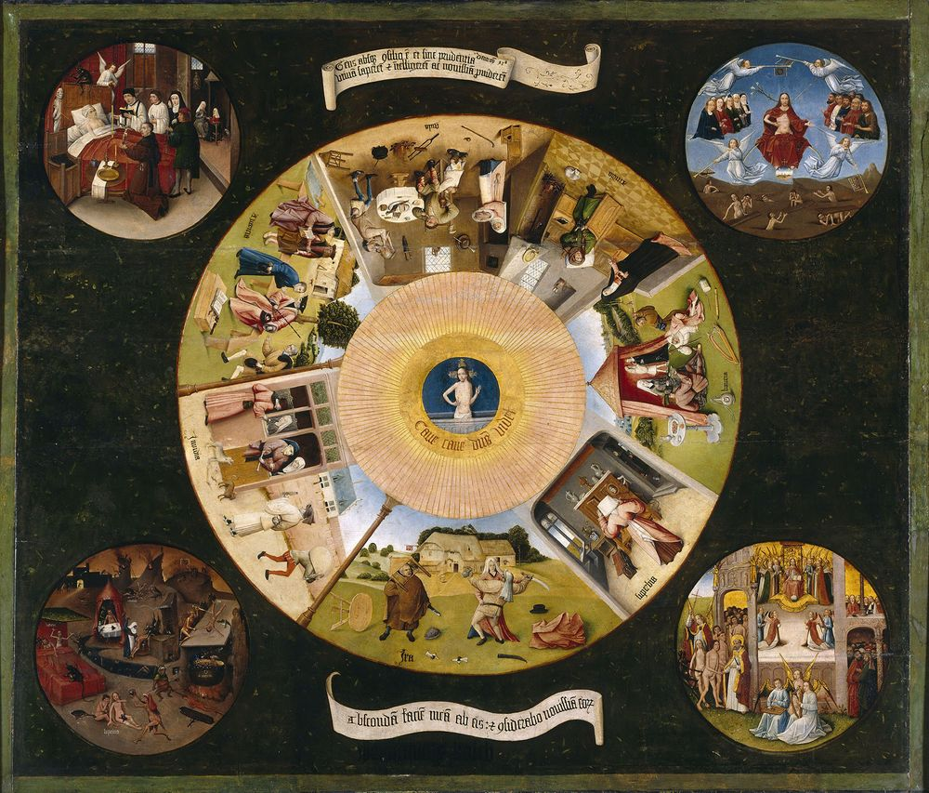
Hiëronymus Bosch: Table of the Seven Deadly SinsTable of the Seven Deadly Sins, oil on poplar panel by Hiëronymus Bosch, 1505–10; in the Prado Museum, Madrid.
The seven deadly sins can be thought of as dispositions toward sin and separation from God. Lust, for example, could result in adultery, which is a mortal sin (also called a cardinal sin), or could lead to somewhat less intentional immoral thoughts that would be classified as venial sins. The deadly sins were a popular theme in the morality plays, literature, and art of the Middle Ages in Europe, such as Dante Alighieri’s The Divine Comedy and Geoffrey Chaucer’s The Canterbury Tales, both of which were written in the 14th century. The theme has also been explored in modern media, including contemporary music and film, such as David Fincher’s crime drama Se7en (1995).

The seven deadly sins and the corresponding seven heavenly virtues
A brief definition of each deadly sin is provided below, along with its countering heavenly virtue, which can be used to overcome the sin.

Britannica Quiz
Christianity Quiz

Pride
Pride is defined in the theological sense as an excessive love of one’s own excellence. Unlike the healthy pride of self-affirmation, sinful pride disposes a person to think more of oneself than one ought to, with no recognition of or appreciation for the gifts one has received from God. Pride causes a person to negate God and take all credit for one’s accomplishments.
Pride can be countered with the heavenly virtue of humility.

Greed
Greed is defined as the immoderate love or desire for riches and earthly possessions. A person can also be greedy for fame, attention, power, or anything else that feeds one’s selfishness.
Greed can be countered with the heavenly virtue of charity.
Explore Britannica Premium!
The trusted destination for professionals, college students, and lifelong learners.

Envy
Envy is defined in the theological sense as resentment or sadness at another’s good fortune or excellence, with an often insatiable desire to have it for oneself. Unlike simple jealousy, envy includes the belief that another’s excellence or blessings lessen one’s own, and it makes one want to destroy another’s good fortune.
Envy can be countered with the heavenly virtue of gratitude.

Gluttony
Gluttony is defined as excess in eating and drinking. Although eating and drinking for pleasure is not seen as sinful, eating or drinking to excess beyond reason is a sin. Drunkenness, which is caused by excessive consumption of intoxicating beverages, is considered a type of gluttony.
Gluttony can be countered with the heavenly virtue of temperance.

Wrath
Wrath is defined as a strong feeling of hatred or resentment with a desire for vengeance. This desire distinguishes wrath from anger that is balanced with reason, which is not a sin. Christian teaching also differentiates between God’s wrath and human wrath, in that the wrath of God is regarded as a manifestation of divine righteousness and justice.
Wrath can be countered with the heavenly virtue of patience.

Sloth
Sloth is defined in the Catechism of the Catholic Church as the “culpable lack of physical or spiritual effort.” The terms sloth and acedia are often used interchangeably, but some theologians distinguish acedia as a form of spiritual sloth that stems from laxity in spiritual or ascetic practices, which leads to discouragement and temptation.
Sloth can be countered with the heavenly virtue of diligence.
The Editors of Encyclopaedia Britannica René Ostberg

seven deadly sins: Facts & Related Content

Written and fact-checked by
The Information Architects of Encyclopaedia Britannica

Facts
Also Known As | seven capital sins • seven cardinal sins

Photos



See All Images →

Related Topics and References
Topics



